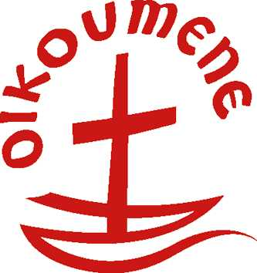
General Secretariat
World Council of Churches
Postal address:

Visiting address:
Phone:
Fax:
General e-mail:
Website:

P.O. Box 2100
CH-1211 Geneva 2
Switzerland
150 route de Ferney
(+41-22) 791 61 11
(+41-22) 791 03 61
infowcc@wcc-coe.org
www.wcc-coe.org

To: WCC Member Churches and
National Council of Churches
in South Korea

Direct dial: | (+41-22) 791 6285
Direct e-mail: | Uz@wcc-coe.org
Direct fax: | (+41-22) 791 6535

Geneva, 7 July 2006

Dear Sisters and Brothers in Christ,

The recent launching of seven missiles, including the Daepodong-2, by the Democratic People’s Republic of Korea (DPRK) confirms the fears expressed earlier by the WCC Executive Committee when it met in Seoul in August 2004. At the time it warned the international community that the Korean peninsula remains a flashpoint in the region and has the potential to ignite a major conflagration. The belligerent and perilous tactics of brinkmanship by North Korea have needlessly heightened military tensions in the Korean peninsula endangering the peace and security of the people in the region.

The World Council of Churches, together with the churches in Korea, has for over two decades played a pioneering role in initiating and supporting the peaceful reunification of the Korean peninsula and its people. The DPRK’s decision to carry out the missile test is greatly flawed because it has intensified military build-up and threat. This will not only isolate North Korea from the international community, but will also add to the sufferings of its people. The missile tests are therefore a setback to the efforts to bring about peace and reconciliation. These developments show how important is the need to revive the stalled Six Party Talks that ended in November 2005, without an agreement after the parties in September signed a Joint Declaration calling for a nuclear free Korean peninsula. Peace on the peninsula can only come through a policy of engagement and mutual trust. The churches and the ecumenical movement should do all in their power to encourage such a course of action.

The World Council of Churches reiterates its commitment to peace and reunification of the Korean peninsula and its people. This goal, however, cannot be achieved through military aggression and threats and requires consistent and concerted efforts to encourage cooperation and dialogue.

The World Council of Churches endorses the 7 July Appeal of the Presbyterian Church of the Republic of Korea (PROK) urging “all concerned countries to normalise the diplomatic relations with North Korea and transform the current situation of conflict into a constructive process towards peace.” The appeal is a reminder to us that Christians who put their trust in the Lord of history should be bearers of the light of hope amidst the prevailing gloom of despondency.

Yours in Christ,

Rev. Dr Samuel Kobia
General Secretary

